Chapter 3, Solution 21

For the circuit in Fig. 3.70, find v₁ and v₂ using nodal analysis.

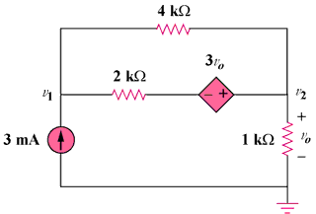

Figure 3.70
For Prob. 3.21.

Solution

(b)
+
–
+
v₃
–

+
v₂
–

3v₀

3 mA
+
–

1 kΩ

v₃

v₂

v₁

3v₀
+
v₀
–

4 kΩ

2 kΩ

(a)

Let v₃ be the voltage between the 2kΩ resistor and the voltage-controlled voltage source. At node 1,
12 = 3v₁ - v₂ - 2v₃ (1)

At node 2,
3v₁ - 5v₂ - 2v₃ = 0 (2)

Note that v₀ = v₂. We now apply KVL in Fig. (b)

- v₃ - 3v₂ + v₂ = 0 v₃ = - 2v₂ (3)

From (1) to (3),

v₁ = 1 V, v₂ = 3 V

